Name: Class:
Introduction
Empirical formula: The formula showing the smallest whole-number ratio of atoms in a substance.
Molecular formula: The formula showing the actual number of atoms of each element present in a molecule of a compound. For example, the molecular formula of glucose is C₆H₁₂O₆ and its empirical formula is CH₂O.

No. | Question | Answer
 | A compound used in ceramics contains, by mass, 22.8% Na, 21.5% B and 55.7% O. What is its empirical formula?
 | A sweet-smelling organic compound contains 0.0556 mol of carbon, 0.112 g of hydrogen atoms and 9.57 × 10²¹ oxygen atoms. Calculate its empirical formula.
 | If a compound contains 75.7% arsenic and 24.3% oxygen by mass, and has a molar mass of 395.6 g mol^{–1}, what is its molecular formula?

The apparatus shown below may be used to determine the empirical and molecular formulas of an unknown compound of general formula C_{x}H_{y}O_{z.}
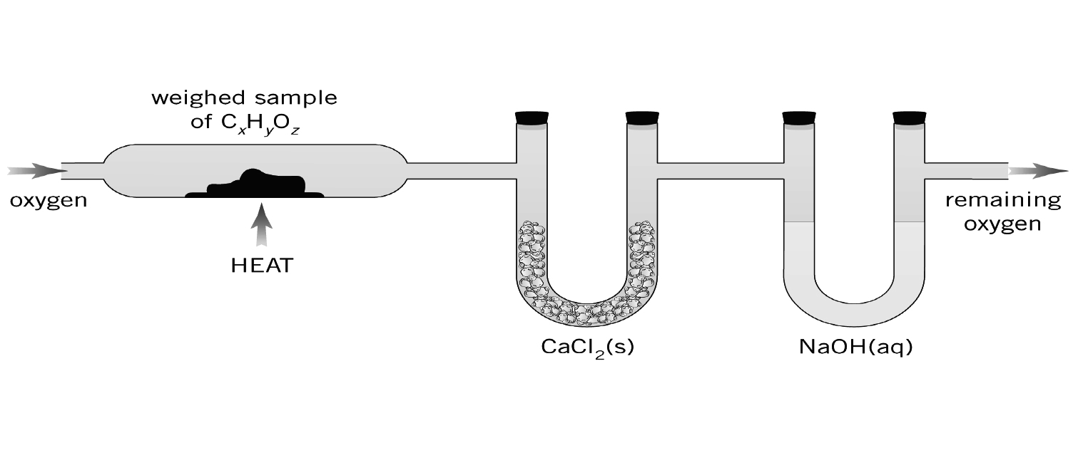
The questions that follow refer to this apparatus.

No. | Question | Answer
 | What is the purpose of the CaCl₂(s)?
 | What is the purpose of the NaOH(aq)?
 | 14.34 g of a hydrocarbon was burned in excess oxygen. The mass of the NaOH(aq) increased by 43.54 g, while the mass of CaCl₂(s) increased by 22.26 g. What is the empirical formula of the hydrocarbon?

A method used to determine the relative molecular mass of a volatile liquid is shown below.

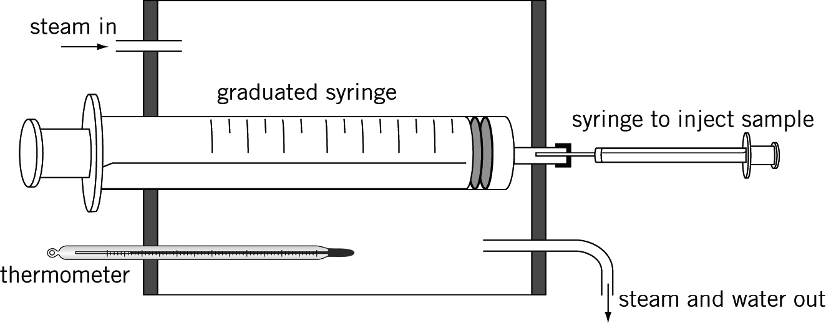

Steam is passed through the outer jacket surrounding a graduated syringe that contains a small, measured volume of air. When the temperature has stabilised, a weighed sample of a few mL of liquid is injected into the graduated syringe, using a small hypodermic syringe. The liquid vaporises and the final volume of air plus sample is recorded. The formula PV = 8.315 nT, where the P is in kPa, V in L and T in K, can then be used to determine the amount in mol of gas in the syringe.

The questions which follow refer to this apparatus.

No. | Question | Answer
 | Why would this method be unsuitable for a liquid with a boiling point above about 90°C?
 | Using the apparatus shown, 0.16 g of liquid was vaporised to produce a volume of 46 mL, at a temperature of 100°C and a pressure of 101.3 kPa. Determine the molar mass of the liquid.
In one experiment an 18.99 g sample of the compound was burnt in excess oxygen. When the gases evolved were passed through anhydrous CaCl₂, its mass increased by 11.38 g. The remaining gases, when bubbled through a NaOH solution, increased its mass by 27.83 g.
In a separate experiment, a 6.21 g sample of the compound was vaporised. The vapour occupied 2.17 L at 200°C and 125 kPa.
Calculate the molecular formula of the compound.

